

**Quick Reference Guide**

**City of Niles IS Staff**

EveryCloud is the email protection system used by the City of Niles. It sits in the cloud in front of our email infrastructure to help protect our nilesmi.net and nilesmi.org addresses against threats such as malware and spam.

EveryCloud will quarantine emails that it determines to be of a suspicious nature.

**Releasing an email from Quarantine**

From time-to-time EveryCloud may flag an email as suspicious that is legitimate. You are able to release this from quarantine and have it sent to your inbox immediately. There are 2 ways to accomplish this; either from the **EveryCloud Web Console** or from the **EveryCloud Tech Quarantine Report** email that is delivered at 7:00 AM and again at 2:00 PM.

**EveryCloud Web Console**

All users have an EveryCloud login to the web console located at the following URL:

<https://cp.everycloudtech.com/>

Your login credentials are your email address and your password.

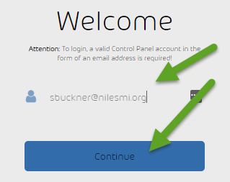 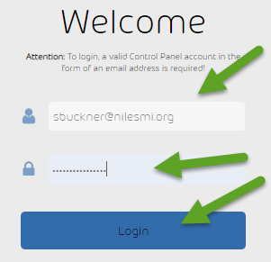

Once logged in to the console you will be able to select the *Date Range* to choose from.

*1. Click the down arrow to the right of the email that you would like to release to your inbox.*

*2. Click Deliver Email*

This process will release the email to your inbox immediately.

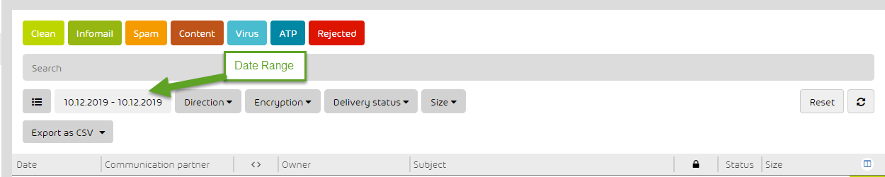

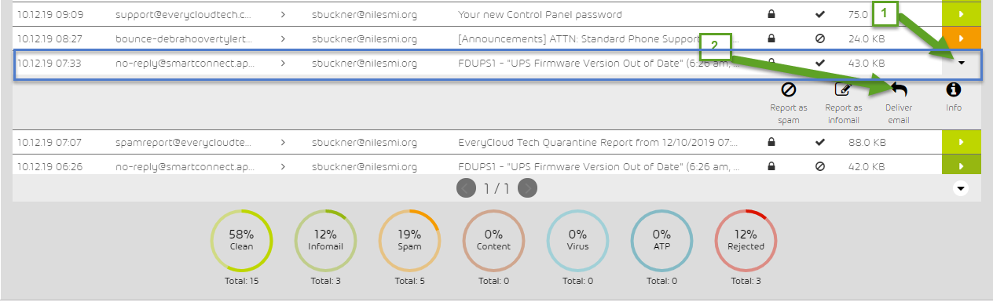

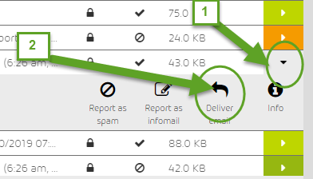

**EveryCloud Tech Quarantine Report email**

You will receive an email everyday with the subject line “EveryCloud Tech Quarantine Report” that is delivered at 7:00 AM and again at 2:00 PM.

From within this email you can choose to:

Click **Deliver** – This will allow this email from the sender to be a approved this instance.

Click **Whitelist** – This will allow any email from this sender to be approved and allowed through for any future instance.

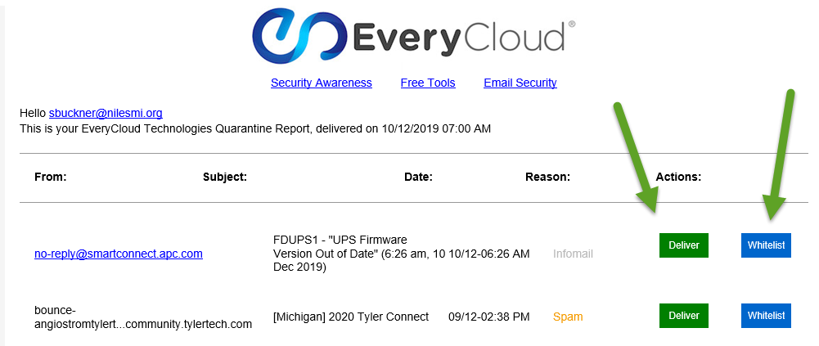

Please note: You have an EveryCloud for every email address if you have multiple nilesmi email addresses.

**Using the EveryCloud Outlook Plugin**

With one click you can blacklist or whitelist emails, report emails as spam or infomail. You can even request a spam report.

The EveryCloud Outlook plugin has been installed on your PC (it can be installed from <https://www.everycloud.com/everycloud-outlook-plugin> if it is missing from the Outlook toolbar).

You will need to perform a login if the plugin is greyed out.

Click the Gear icon on the plugin.

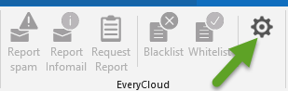

Enter your username / email address, password, then click save:

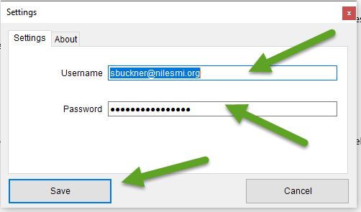

From Outlook you are now able to select and highlight an email from your Inbox then select whether to.

***Report spam*** – This will inform Everycloud to mark emails from this sender as spam and move them to quarantine in the future.

***Report Infomail*** – This will inform Everycloud to mark emails from this sender as Infomail and move them to quarantine in the future.

***Request Report*** – This will generate and send you a new spam report. This is very helpful if you would like to avoid having to log in to the EveryCloud web portal and would rather release the email from the spam report email report. This also allows you to release these emails from other times than 7:30 AM and 2:00 PM. These reports generally arrive with 15 minute after the request has been made.

***Blacklist*** – This will block any emails in the future from that domain name.

***Whitelist*** - This will allow any emails in the future from that domain name.

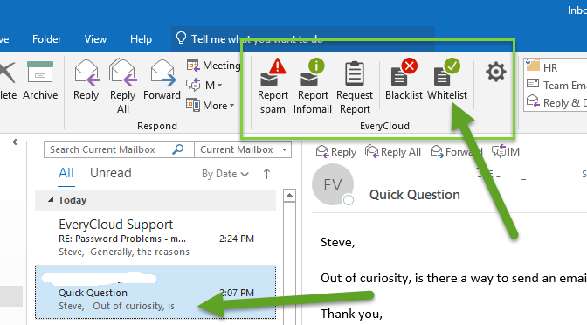

**Resetting login passwords**

Please follow these steps if you have lost or forgotten your EveryCloud login password.

1. Open <https://cp.everycloudtech.com/>

2. Ender you username / email address then click **reset password**, then click **submit**.

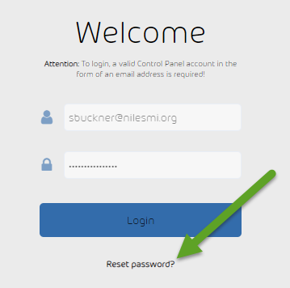 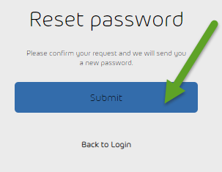

3. An email will be sent to your inbox

4. Click the Activation Link to verify, this will bring you to the EveryCloud login page

5. Use the new password credentials provided to gain access to the site. Be very careful to enter the password correctly. If you use cut / paste be sure copy only the text provided, making sure to include all characters and exclude all spaces.

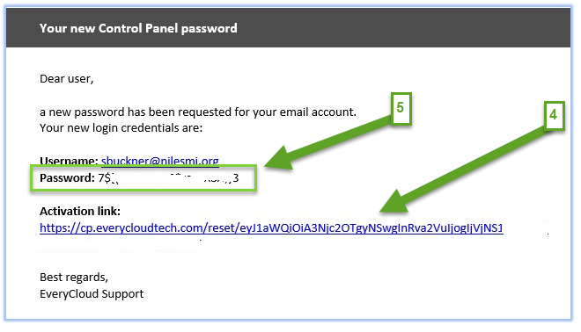

6. It is recommended that you change your password to something more to your liking once you have logged in successfully

7. Please open a ticket with the IS Helpdesk ([helpdesk@nilesmi.org](mailto:helpdesk@nilesmi.org)) if you have difficulty resetting your EveryCloud password.

Thank you,

City of Niles IS Staff